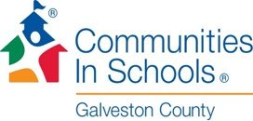 Donation Form
Please complete this form and mail it with your donation to:
Communities In Schools Galveston County
1727 Bayou Road
La Marque, TX 77568

CONTACT INFORMATION:
Name: _______________________________________________________________________
Address: ______________________________________________________________________
City, State Zip: __________________________________________________________________
E-Mail Address: _________________________________________________________________
Phone: ______________________________________ Please circle type: Home/Work/Mobile
o Enclosed is my check for $_________
Please make checks payable to Communities In Schools Galveston County.

I would like my donation to be toward:
_______________________________________________________________________________________________________________________________________________________________________________________________________________________________________________________________

How did you hear about Communities In Schools Galveston County? __________________________________________________________________________________________________________________________________________________________________________
Thank you!
If you have any questions, please contact the office at 409-765-9395
Communities In Schools Galveston County
is a 501(c)3 organization.
All gifts are tax-deductible.

